Bay Nature Local Hero Awards Gala
Look deep into nature, and then you will understand everything better.

Organizational Sponsorships 2019
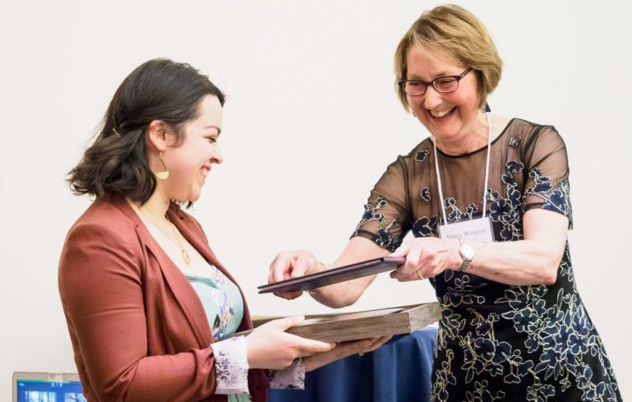

The Bay Nature Local Hero Awards Gala is an annual event honoring conservation heroes in the San Francisco Bay Area. 250 nature advocates, outdoor enthusiasts, and conservation agency leaders come together to honor our Local Heroes and enjoy an hors d’oeuvres reception, elegant sit-down dinner, and nature-themed auction.

The gala will be held on March 31st, 2019 at The Berkeley City Club. This year’s event will feature an exclusive VIP reception for sponsors of $1,000 or more, with the opportunity to mingle with Bay Nature heroes, board, staff, and special guests in an intimate environment.

Sunday, March 31st, 2019
Berkeley City Club
2315 Durant Avenue
Berkeley, CA 94704

Program
5:00 – 5:45 p.m. VIP Reception
5:30 – 7:00 p.m. General Reception
7:00 – 8:30 p.m. Dinner & Program

Raise your visibility with Bay Nature’s dedicated following

55,000  Monthly visitors to baynature.org | 8,500  Facebook followers | 15,000  Quarterly Bay Nature magazine readers | 10,300  Connections  E-newsletter subscribers | 1,000  Print invitation recipients | 250  Local Hero Awards guests

Join the community of Bay Nature supporters

2019 Local Hero Awards sponsors:
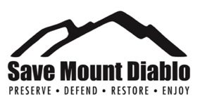
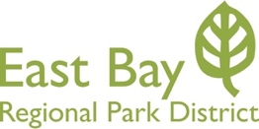
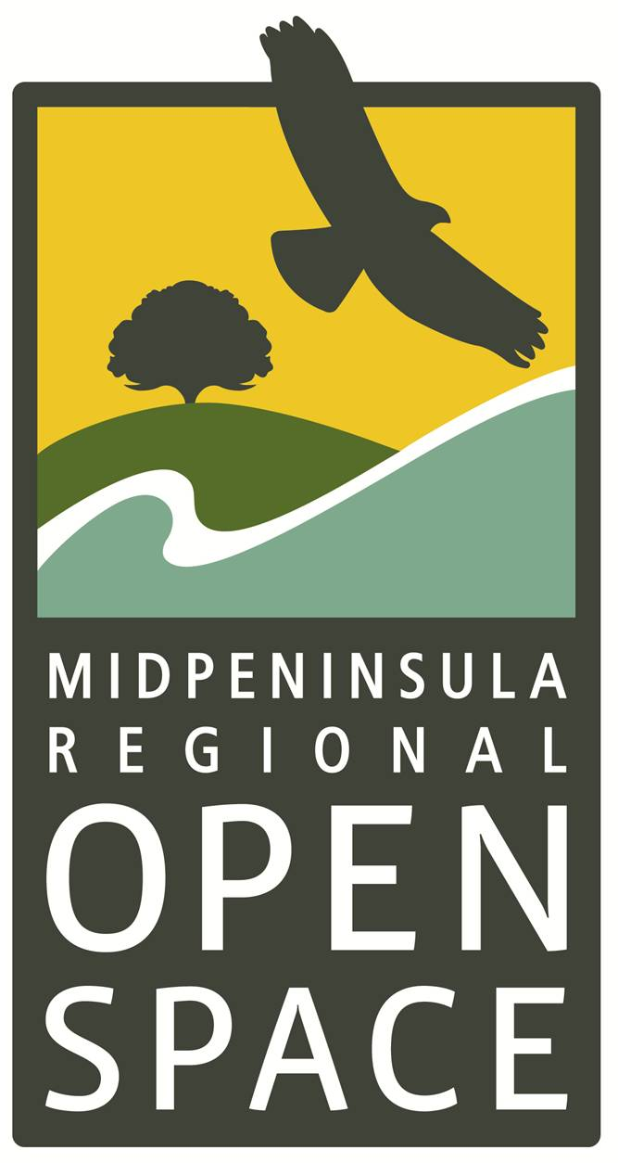

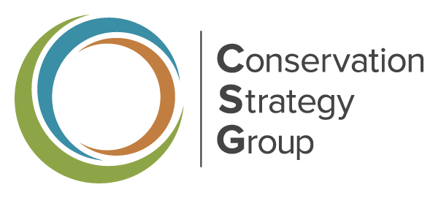
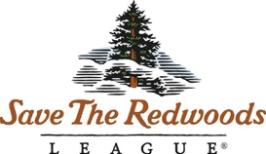
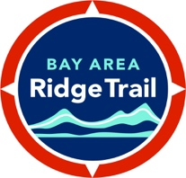

Bay Nature Local Hero Awards Gala 2019

Organizational Sponsorship Benefits
Figure 1
 | Coho Salmon |  | Mariposa Lily |  | Green Hairstreak | Anna’s Hummingbird | Valley  Oak
BENEFITS | $1,000 |  | $2,500 |  | $5,000 | $10,000 | $15,000+
Event Tickets | 2 tickets |  | 5 tickets |  | Table:  9 tickets | 12 tickets | 15 tickets
1-year subscription to Bay Nature magazine
Recognition on Local Hero Awards webpages
Recognition in event invitation
Recognition in event program book
Invitations for you and your guests to VIP reception
Featured on event signage
Featured in event slide show
Logo printed in event program book
Recognition on Bay Nature’s social media channels
Featured in event email communications
Banner ad in Bay Nature e-newsletter
Invitations to issue release parties and special events
Half-page ad in Bay Nature magazine
Don’t see a sponsorship level that works for you? Please contact Laney Ennis at laney@baynature.org or (510) 528-8550 x103 to discuss custom sponsorship packages.

For federal income tax purposes, you can deduct as a charitable contribution the price of your sponsorship less the fair market value ($100) of each ticket used.

